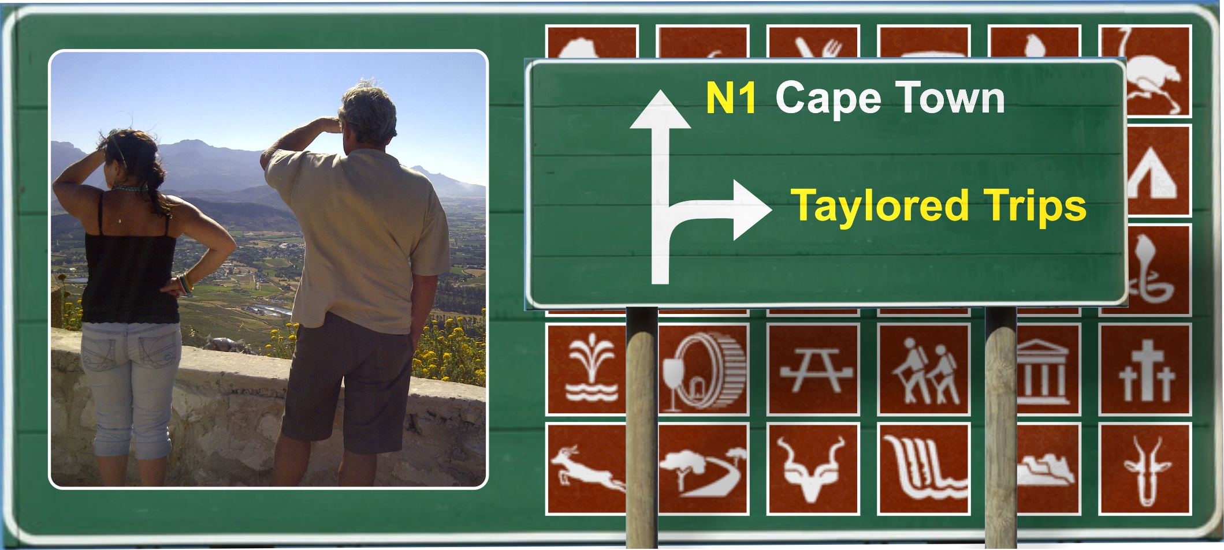

Taylored Trips - Time with family and friends
Waterval Resort Vanrhynsdorp
November 2013

Time! It seems to be in short supply wherever you go, but especially when you are on a weekend away and sunny South Africa just keeps on throwing more and more interesting places for you to see but you don’t have the Time to take that turn-off you just passed or to stop to get out of the car to admire the view or to move that tortoise off the road. Yip, it rules us all.

Anyway, enough philosophying for now, let’s get to the weekend.

Five of us climbed into the Kombi on Saturday morning and headed north. We joined two other couples in Clanwilliam and another couple in Graafwater and then there were eleven of us in four vehicles and we were on our way to the Waterval Resort on Ouberg near Vanrhynsdorp.

We went straight through Graafwater on a gravel road to the Heerenlogement Caves (which Nelly kindly translated into gentlemen’s lodging) where the pioneering early Dutch settlers overnighted on their way to the copper fields around the Springbok area. They engraved their names on the wall of the cave with the date which was not purely graffiti in those days but more of a reference that they had passed through here in case they never returned. There is also a turn-off to the left before you get to the cave which goes down to a grave yard and a pit/well where Oloff Bergh found water on 9th November 1682. We didn’t do the 9kms there and 9kms back because of the Time factor but this is what it looks like.

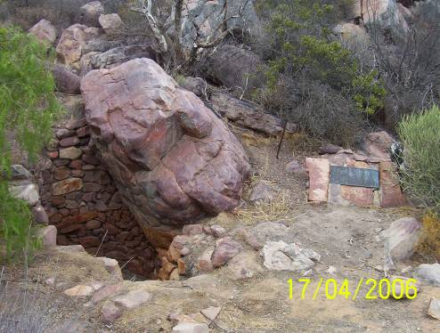

And this just proves that in 2006 I found the Time to do the 18km detour on the way back from a lovely Easter holiday in Strandfontein.

Anyway, back to the present.

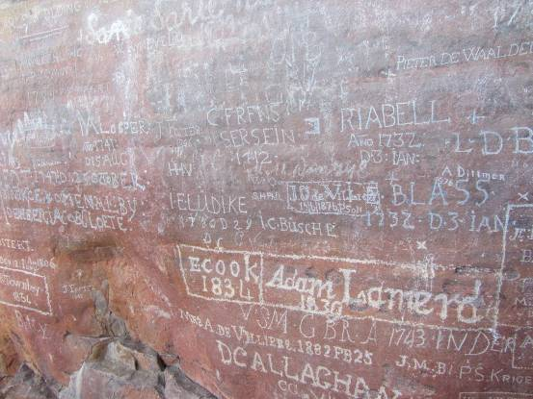

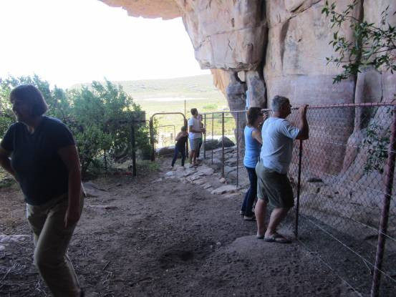

And here is a then and now view from the top.

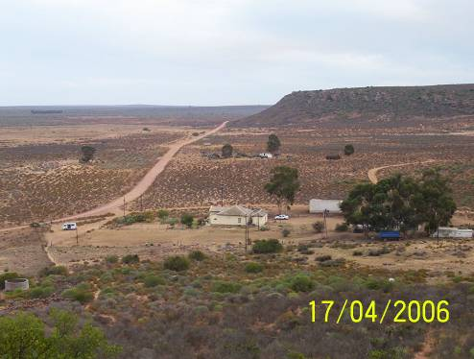

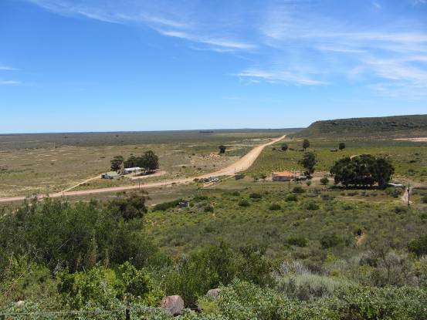

The trees haven’t grown much but two buildings have disappeared and the main house has been painted and renovated a bit. It was obviously frequented more in 2006 as is evident in the path and parking area showing more signs of traffic than the present picture.

We went on to Vredendal and stopped for some supplies and then went back through Klawer, left on to the N7 and took the turnoff to the right to Gifberg.

We stopped at the water crib to fill empty water bottles with lovely cool, crisp mountain water

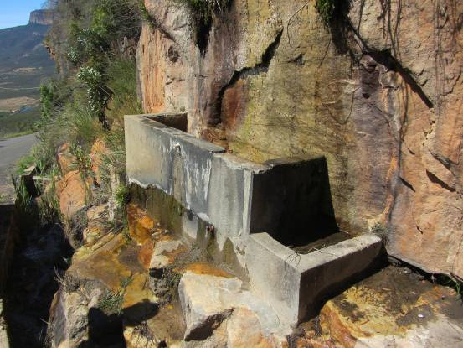

and enjoyed the amazing views from up here.

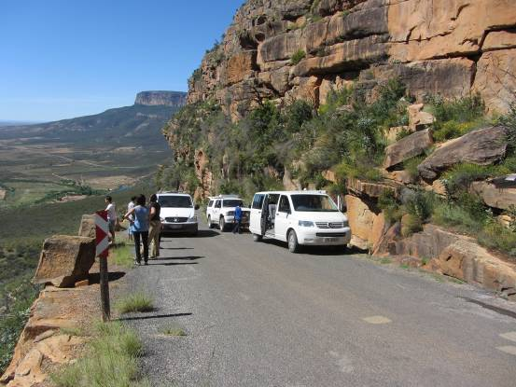

We turned left at the top of the pass and went past the turnoff to Gifberg Rusoord because of that factor mentioned earlier called Time. I wanted to show the troops the Spoelgat hiking trail which looks like this,

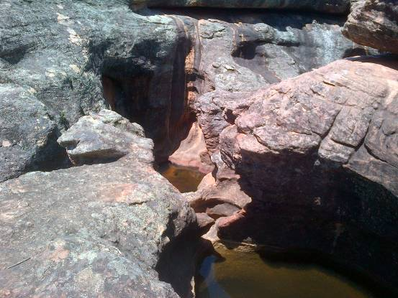

this,

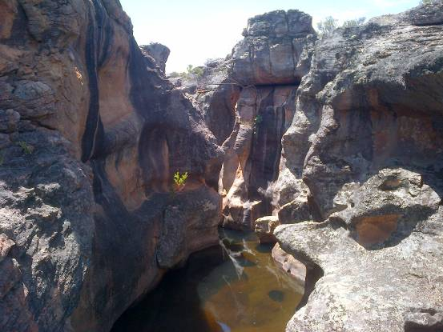

and this.

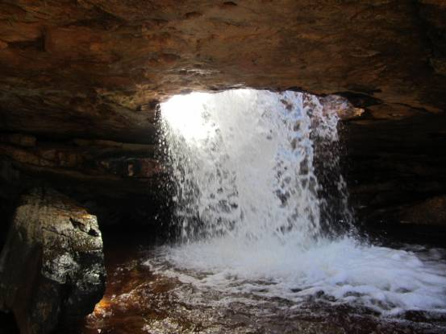

But it wasn’t to be, maybe next Time.

The road takes you over the mountain, through a drift and past rooibos plantations and just before you start doing down Ouberg to the resort we pulled off the road to go and see a bushmen cave complete with a few faded paintings.

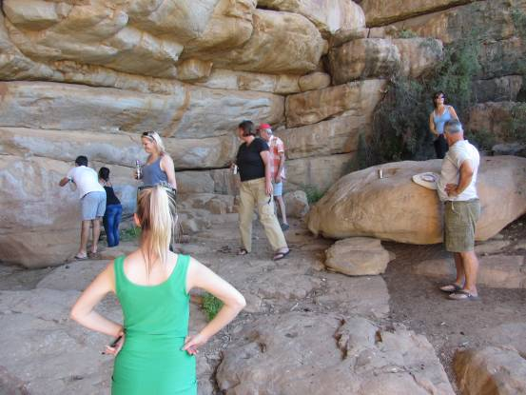

And then we were there. Johan and Marieta’s Waterval Resort.

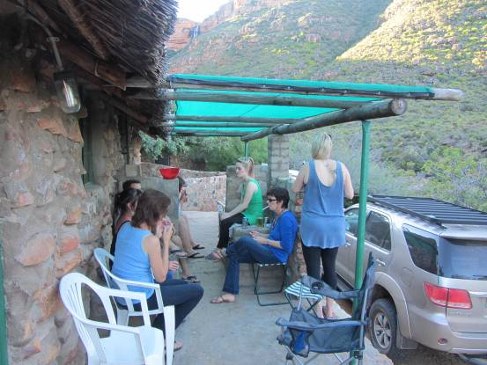

The adjacent lapa was a winner and a good time was had by all but not before Donna, Schalk and I took our first walk to the waterfall.

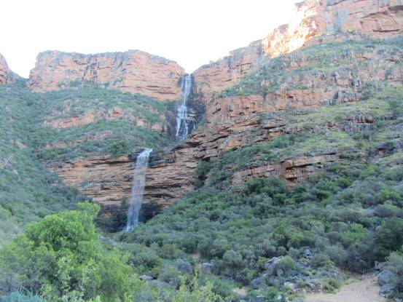

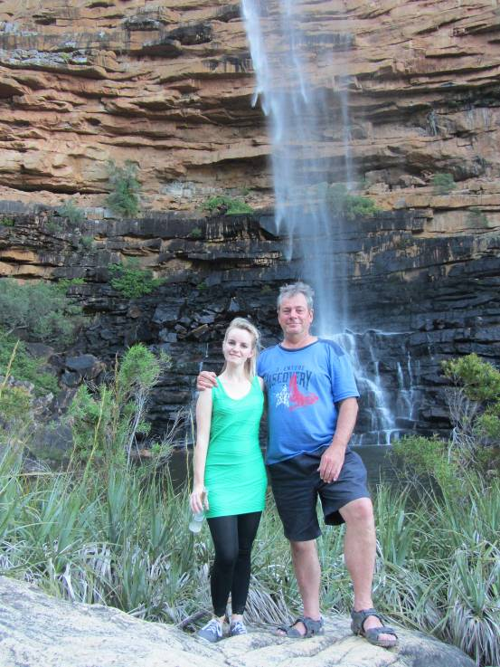

Then the party started.

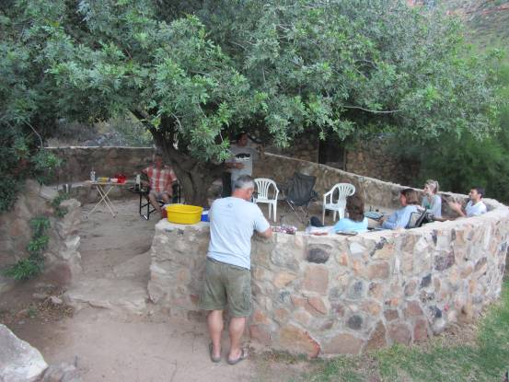

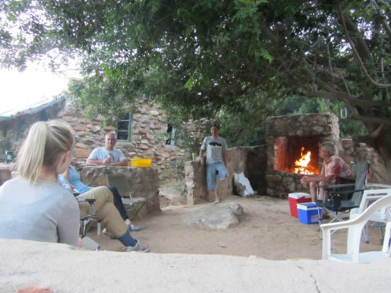

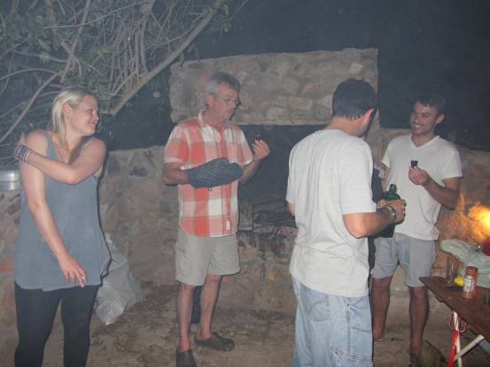

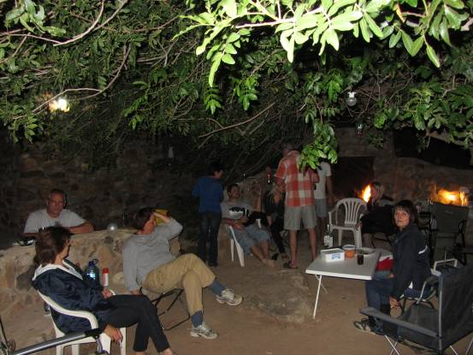

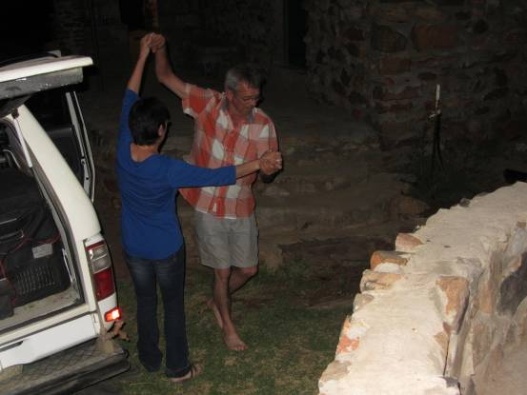

The next morning we all trekked off to the waterfall and some of the more adventurous ones went for a chilling swim in the pool for that exhilarating thrill that only an ice cold waterfall straight out of the mountains can provide.

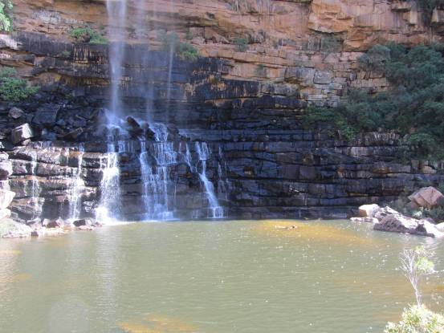

Some of us had more Time than others and were able to stay for another night in paradise and seven of us headed home on a slightly different route than normal.

We went up the amazing Vanrhyns Pass and stopped on top of the escarpment for a rejuvenating view over the knersvlaktes. The plains below were given that name by the Dutch pioneers mentioned earlier because of the shale that ground on the wagon wheels which sounded like the grinding of teeth.

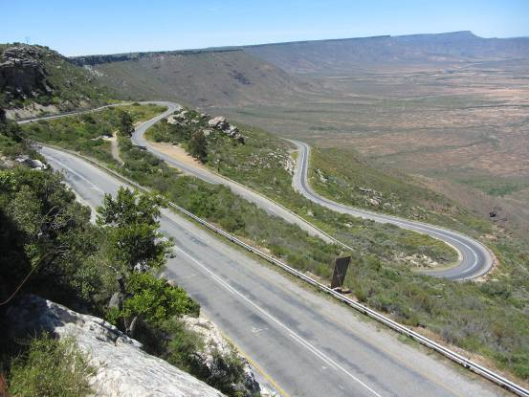

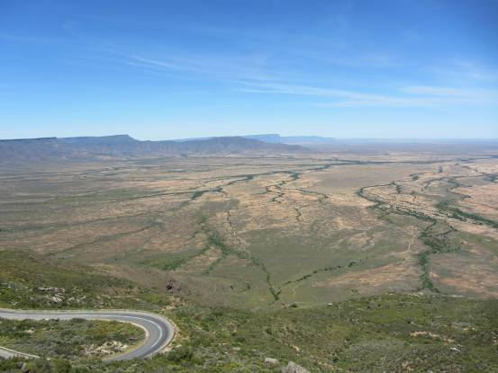

We turned right into the buzzing metropolis of Nieuwoudtville to see the motorbike collection at Protea Motors but they closed at 11.00am and we got there at 12.00. Needless to say we were very disappointed because this was to be the highlight of the trip for some of us. I had been there before when they were open and took one or two photos.

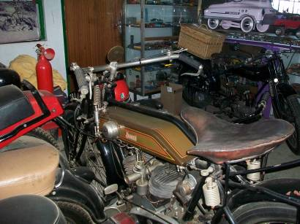

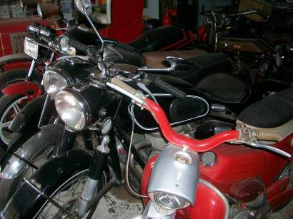

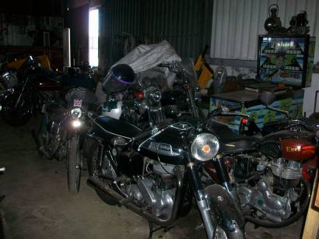

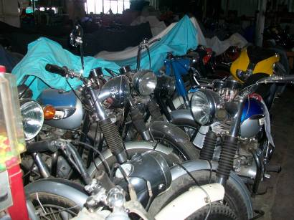

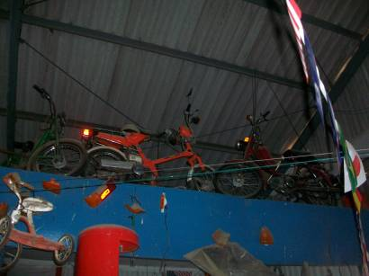

Unbelievable! Maybe it was a good thing that they were closed because I think we would still have been there. But for every door that closes, another one opens and we were gifted with enough Time to go and see another spectacular waterfall or two just up the road.

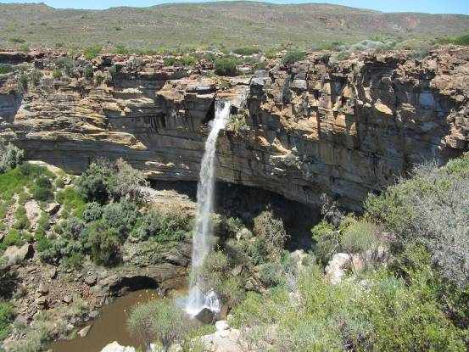

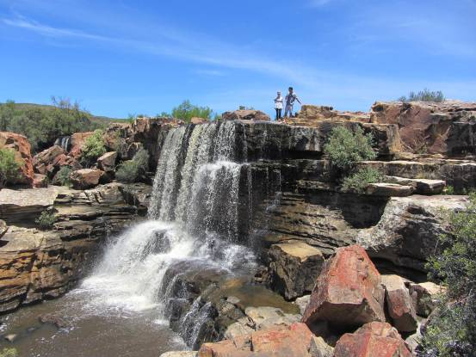

Unfortunately though, there was not enough gifted Time to go and see the windmill museum or the kokerboom forest as we headed south out of Nieuwoudtville with its very impressive sand stone church. We weren’t able to stop at the glacial pavement or the long shed padstal either so maybe a few more small photos from previous trips to whet the appetite to ensure that there will be a next Time.

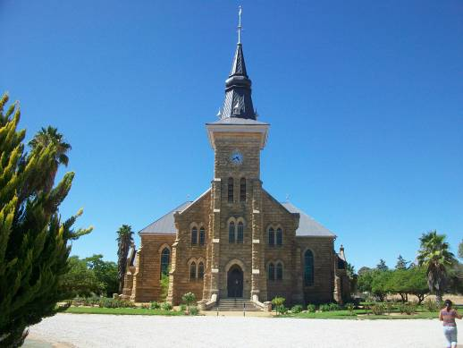

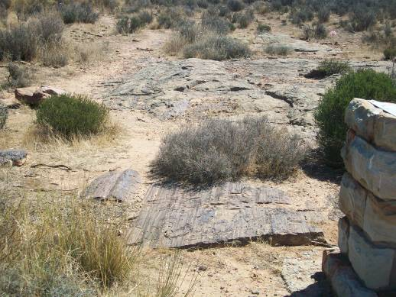

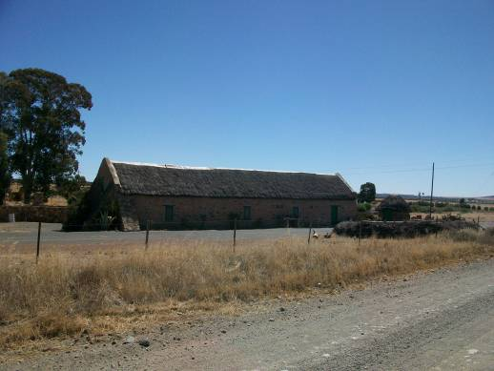

We went down the breathtaking Botterkloof Pass and marveled at the amazing vistas spread out before us as far as you can see.

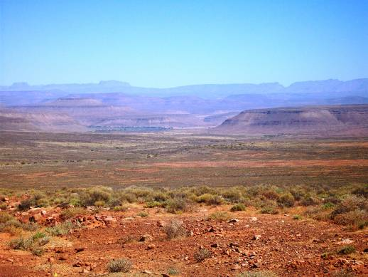

What a beautiful country we stay in.

We made a brief stop at the Engelsman se graf for a leg stretch and saw that the fresh flowers that used to mysteriously appear there doesn’t happen any more.

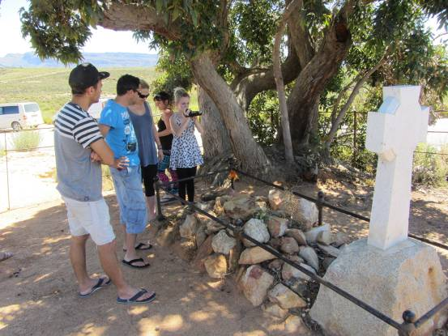

We went over the Pakhuis Pass and it was the first time that I have driven the pass since it has been tarred. We sped past C. Louis Leipoldt’s grave and the Soldaatskop and stopped in Clanwilliam for something to eat and then we parted ways with Jason and Natalie as we went south and they went west.

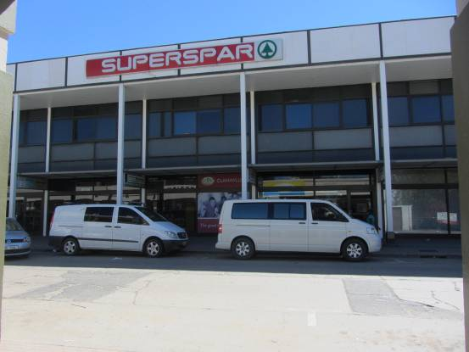

All in all we had a wonderful weekend and everyone got home safely.

Till next Time, Keep on tripping!

