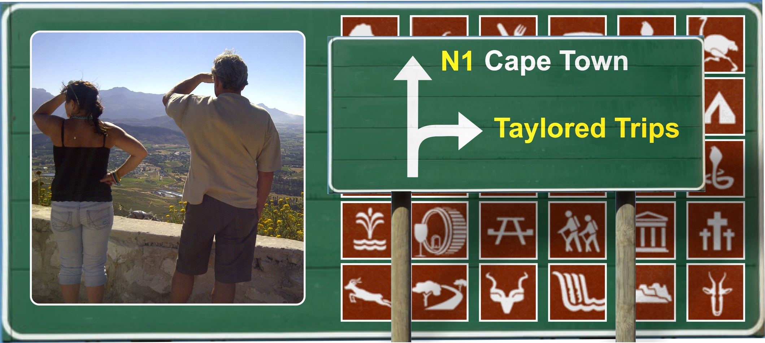

Taylored Trips – Places of Interest
Weskus

The west coast or Weskus as it is popularly called by us Capies stretches all the way from Melkbosstrand to Alexander Bay but this story is restricted to a radius of ± 20kms from the town of Vredenburg.

The “Things to do” in this area just go on and on so we won’t even mention the normal things like the Strandloper beach restaurant or the wind and kite surfing. If it’s wind you want though then you have come to the right place. Even the trees and bushes are shaped by it.

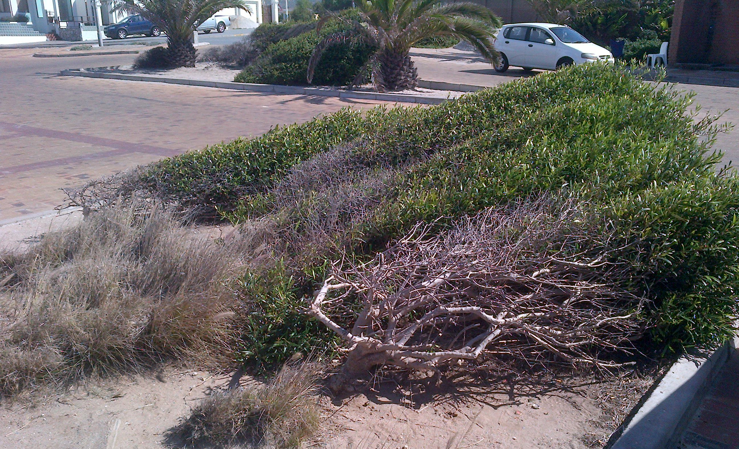
Saldanha Bay
But on a good day there’s nothing to touch the Weskus.

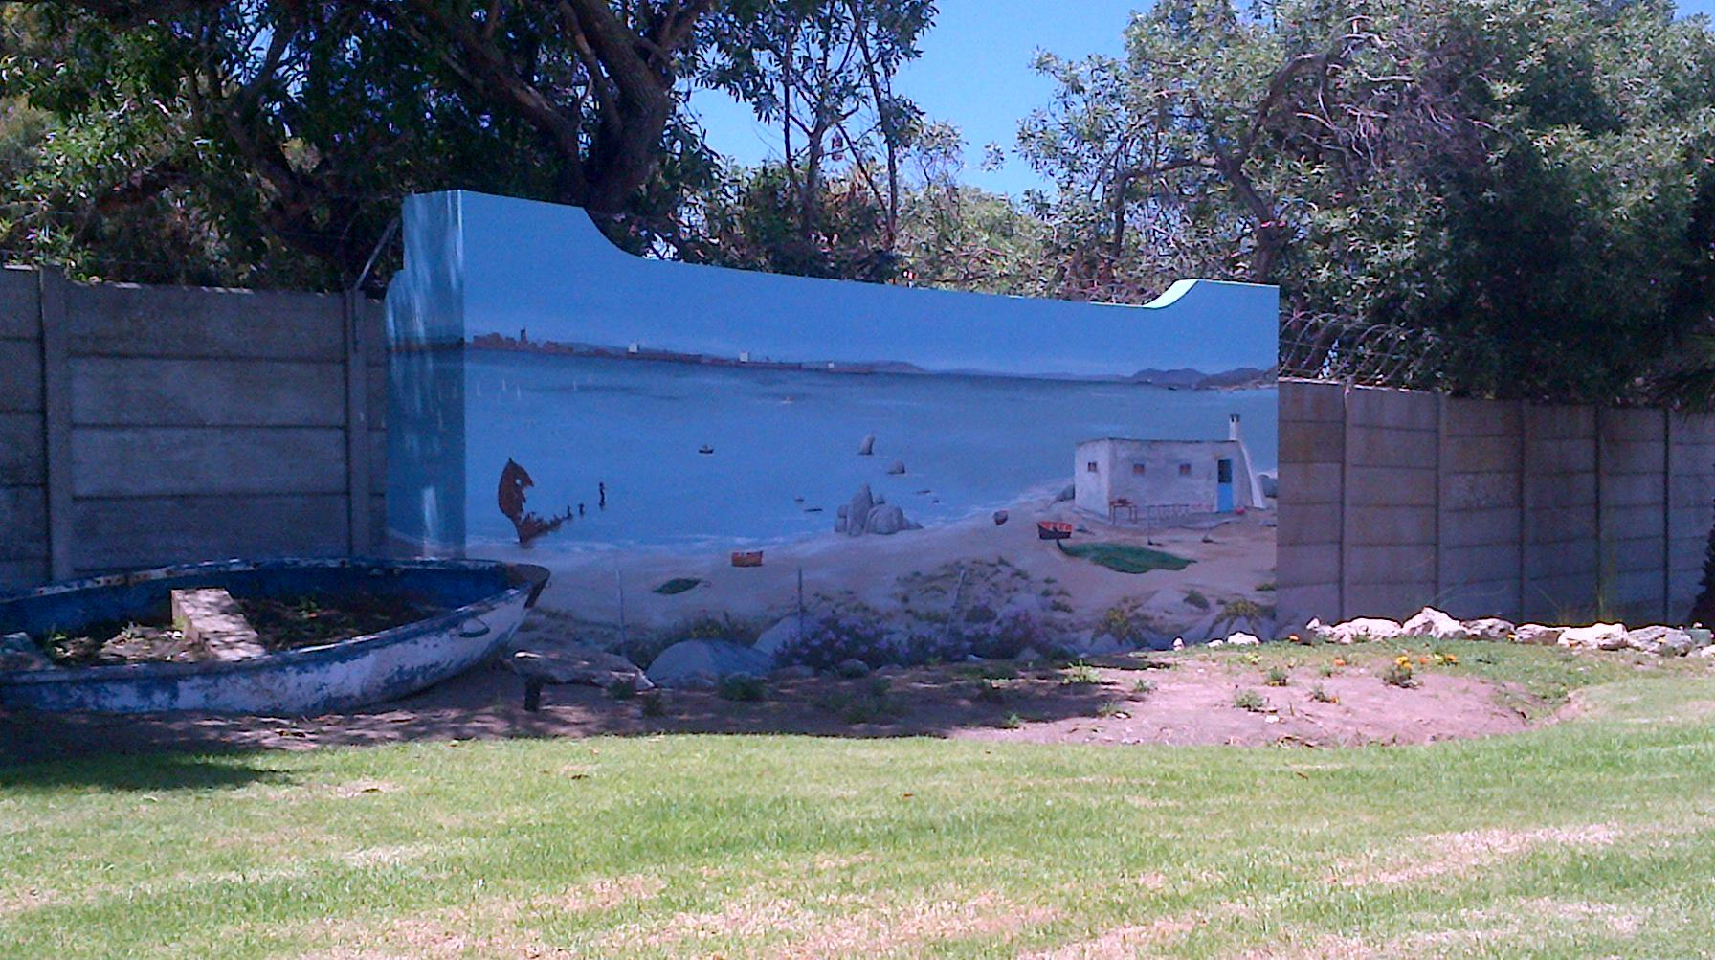
Saldanha Bay
When entering Saldanha Bay you are greeted with this beautiful mural on the wall at the caravan park painted by a Mr Carstens from the little town of Redelinghuys. A destination in its own right well worth the effort, if only to see his other 22 odd murals around that quaint town.

Every spring around August/September people from all over the world are drawn to the area to witness the wild flower display which is unique to the greater West Coast/Namaqualand.

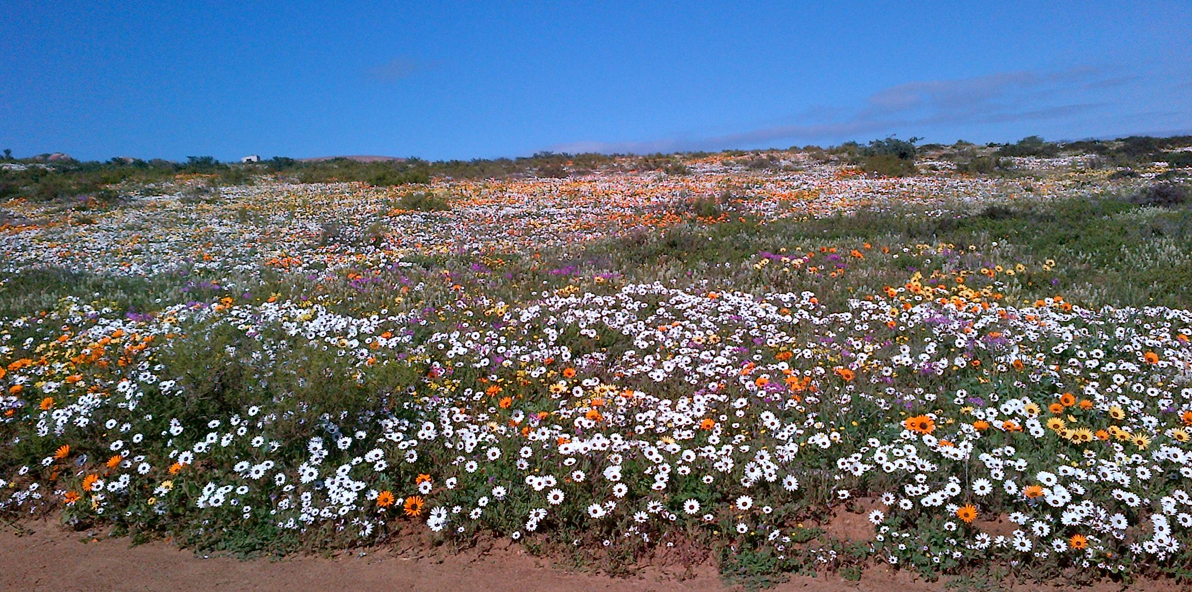
Seeberg in the West Coast National Park outside Langebaan on the lagoon

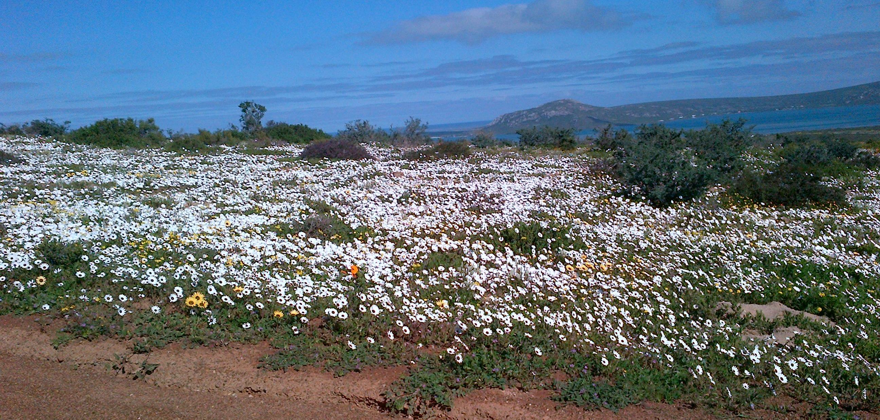
Seeberg in the West Coast National Park outside Langebaan on the lagoon

On the double road between Saldanha Bay and Vredenburg is a turnoff to Jacobsbaai but if you are feeling a bit more adventurous take the back road from Saldanha, through Diazville and Tabakbaai on a sand road along the coast to Jacobsbaai.

There is not much more than a few houses, a restaurant and a lovely bay but if you want unspoilt coastline and peaceful tranquillity, maybe a bite to eat and a stroll along the beach, look no further.

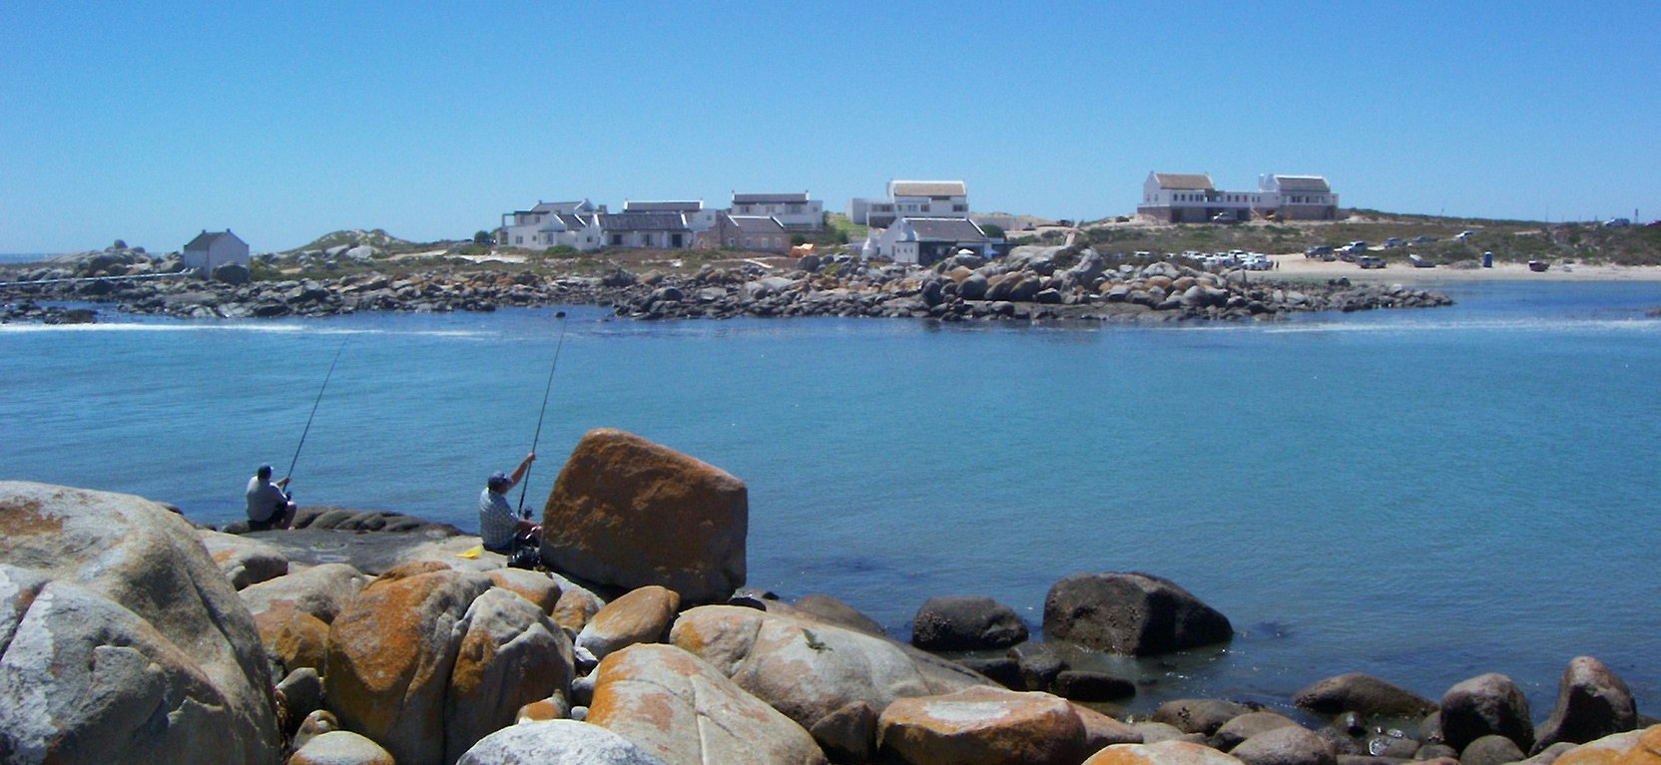
Jacobsbaai

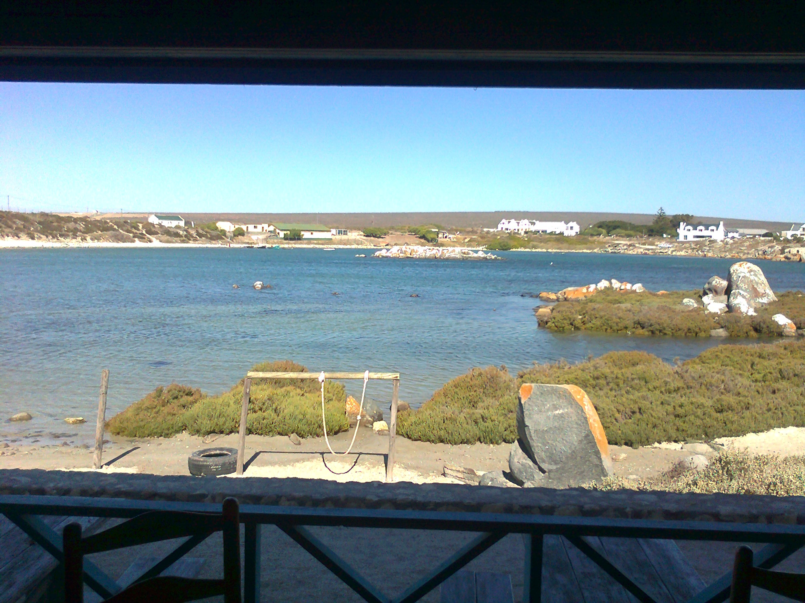
This taken from the restaurant

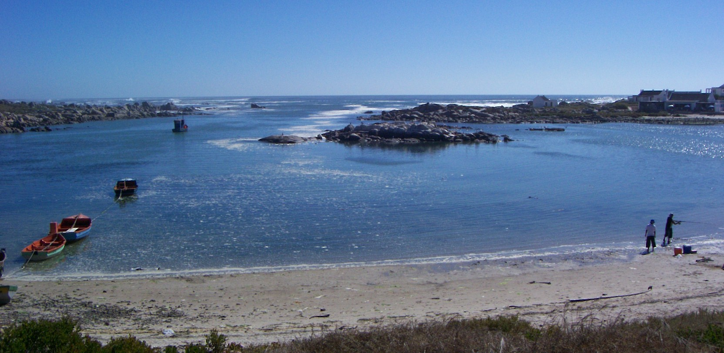
Jacobsbaai
The picturesque Greek look-a-like resort of Mykonos on the Langebaan Lagoon has boating, eating, gambling and accommodation to mention just a few of the attractions. There is so much to do here that even a long weekend wouldn’t give you enough time to enjoy all the activities properly.

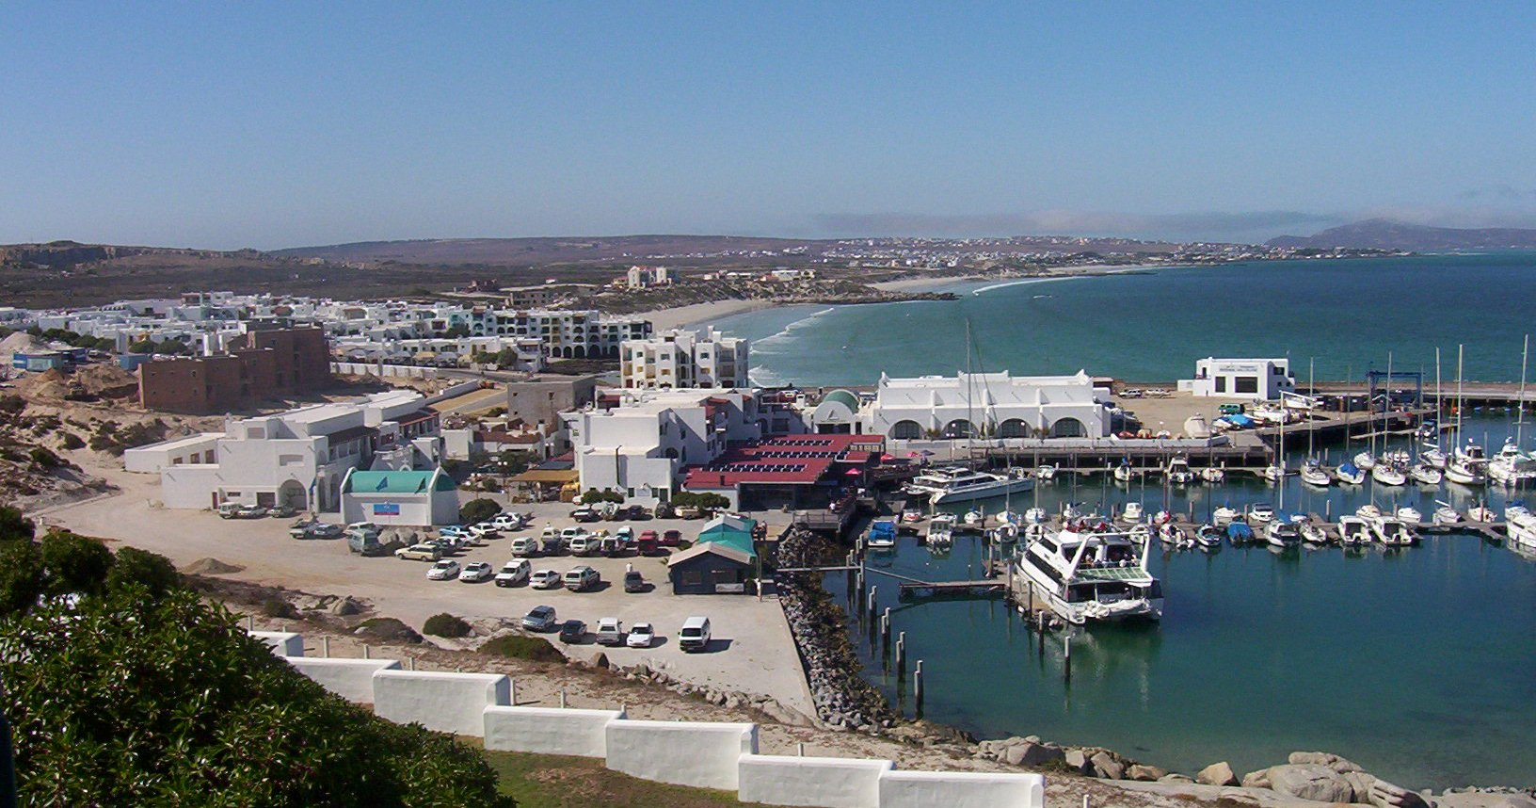
Mykonos resort

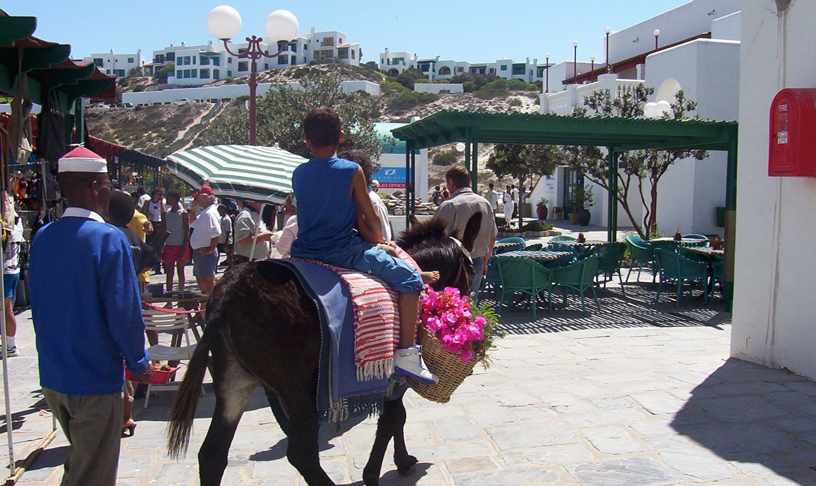
Mykonos resort
Just down the road is the little fishing village of Paternoster, made famous by the fishermen’s cottages, illegal crayfish, the Panty Pub at the Hotel and of course Tietiesbaai.

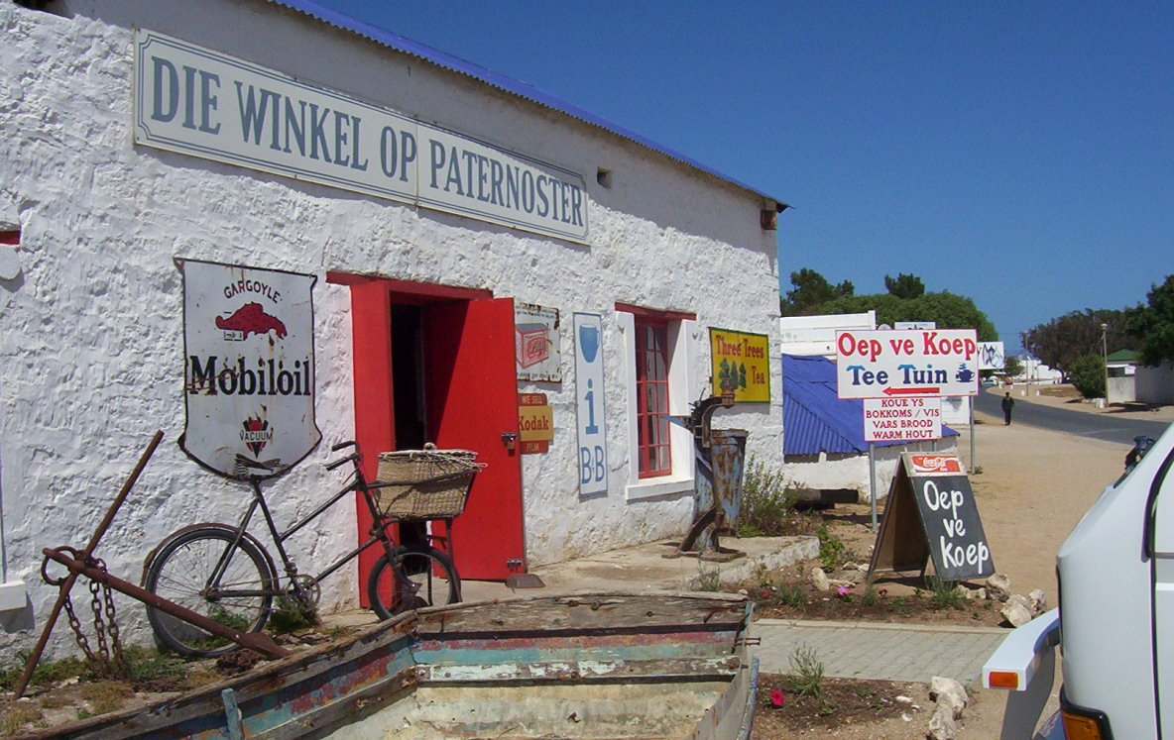
The classic “Oep ve Koep” shop in Paternoster

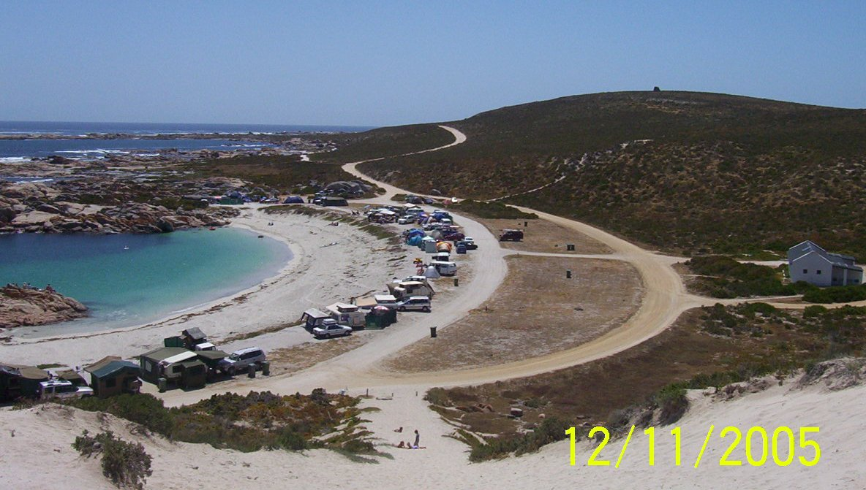
The very popular Tietiesbaai
Tietiesbaai as you can see is a beautiful little bay which lies in the Cape Columbine Nature Reserve and is very popular for camping. The hill in the background is where the name of this little slice of heaven comes from but don’t be fooled by the alluring turquoise calm water of the bay. It is freezing cold and will numb your feet in no time if you dare try and go for a swim. This is wetsuit water and home to the famous West Coast Rock Lobster or crayfish as we know it!

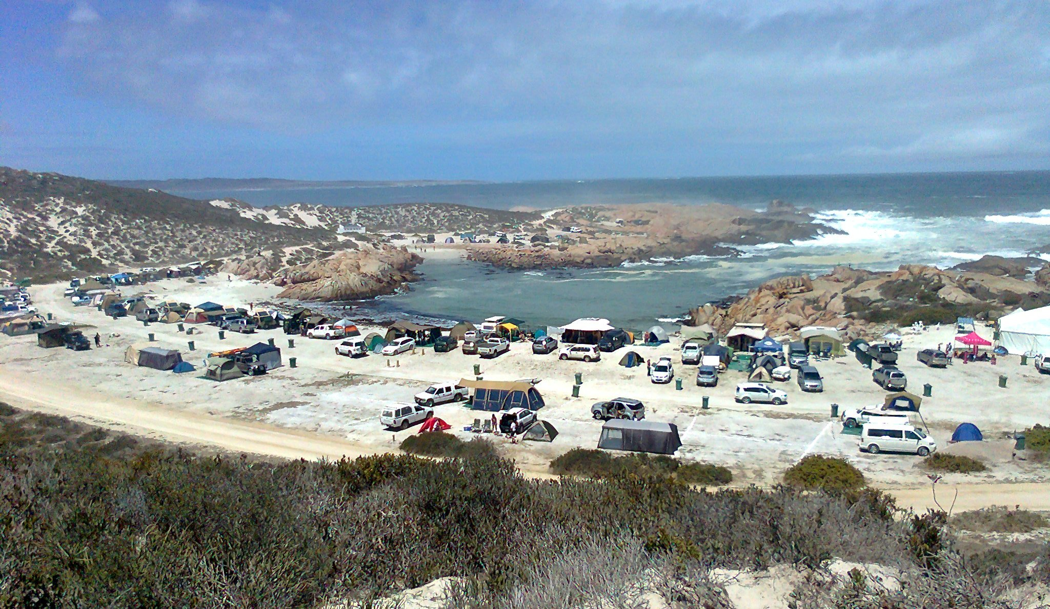
Camping at Tietiesbaai
If one chooses to camp anywhere else in the reserve other than Tietiesbaai itself, as seen below, then you have to be self-sufficient as there are no facilities at all.

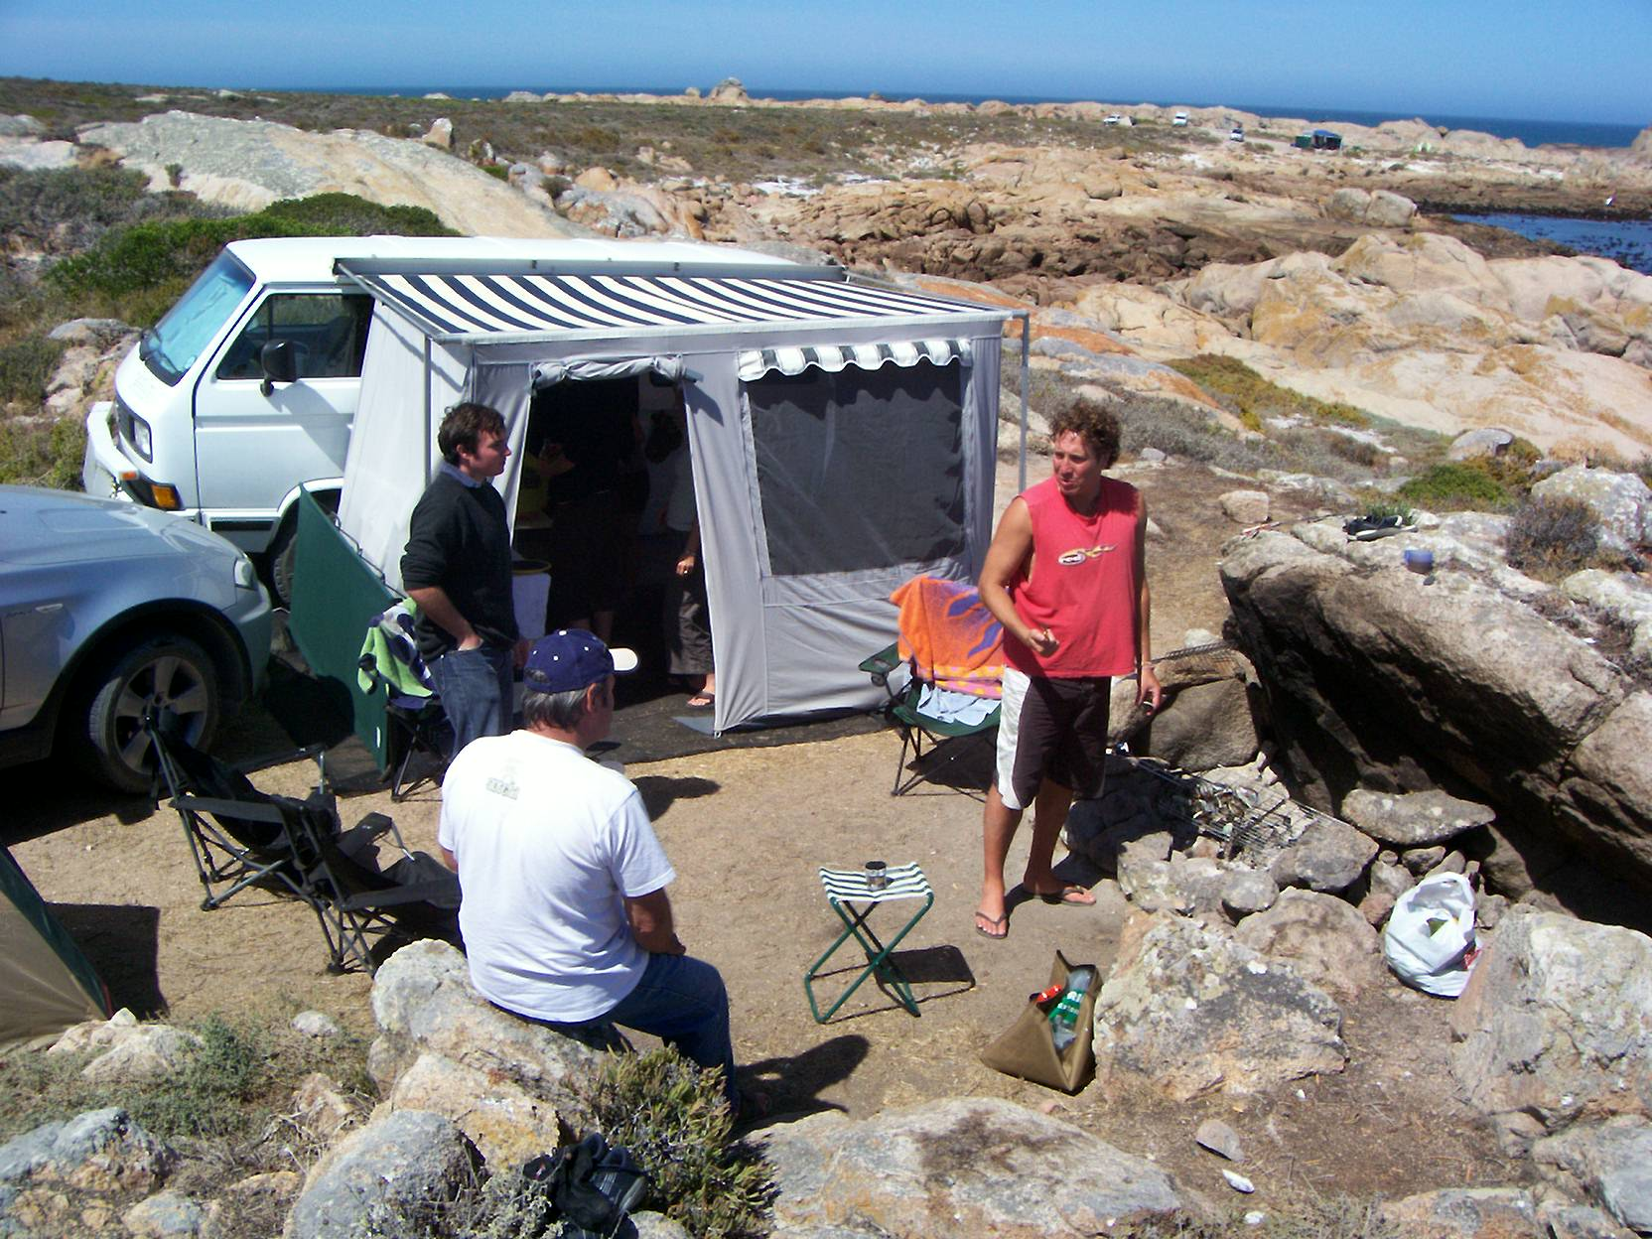
Camping at Cape Columbine

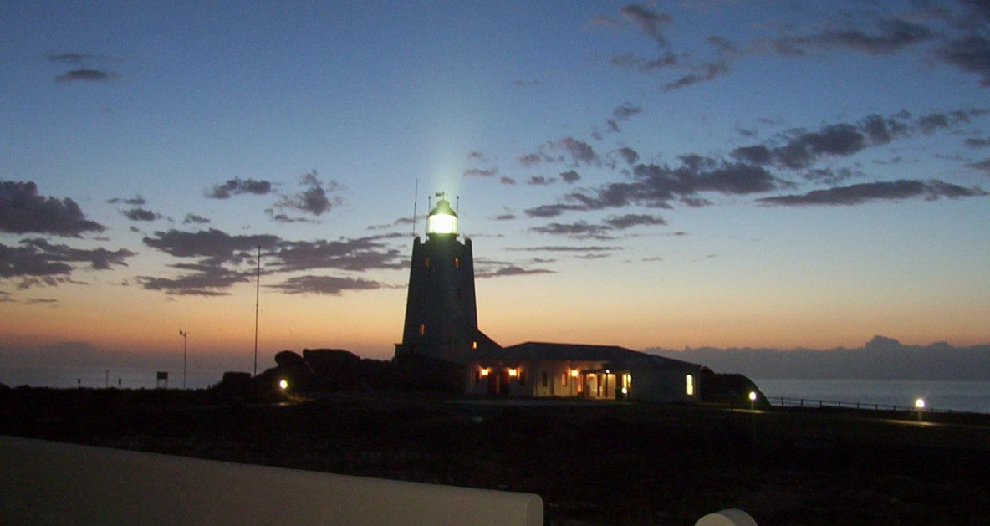
Cape Columbine lighthouse
The Cape Columbine lighthouse, built in 1936, is the last manually operated lighthouse built in South Africa and is usually the first lighthouse seen by ships coming from Europe or the Americas. The beam is visible from about 50kms and it is built on an outcrop of rock known as Castle Rock.

Three former lighthouse keeper’s homes have been turned into guesthouse accommodation and it is one of very few places where one can stay at a lighthouse.

Cape Columbine takes its name from the ship Columbine that was wrecked just north of the lighthouse in 1829.

In the nature reserve is a very special place called The Beach Camp literally right on the beach and they offer backpacker A-framed accommodation or tents. Only people booked in at the Beach Camp can make use of the facilities, such as the bar and the famous catapult. There is a drum across the bay that you can shoot at and they have kayaks for rent.

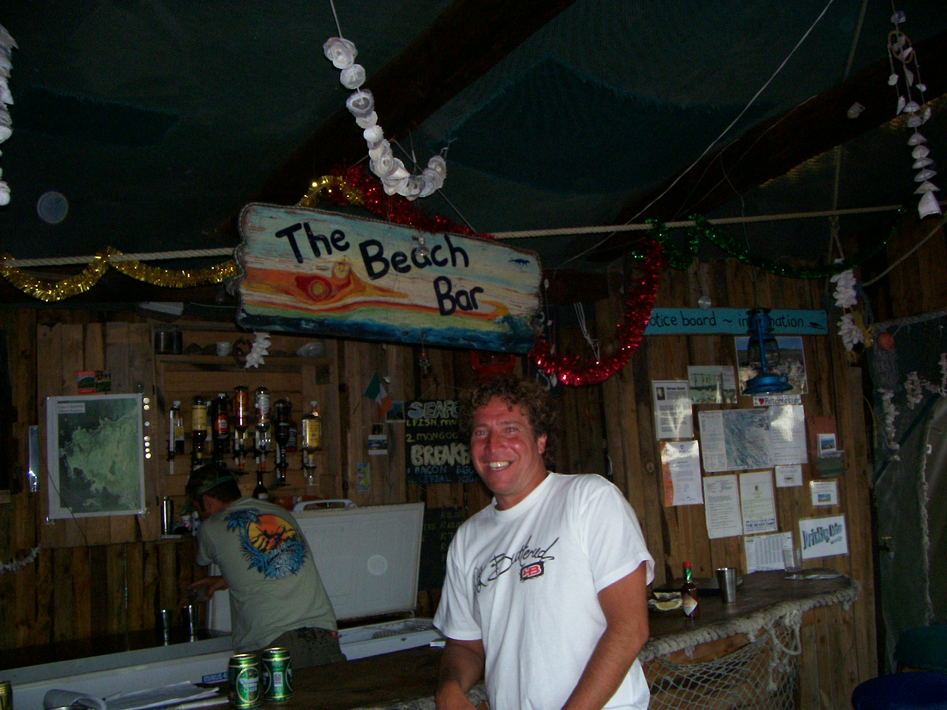
The Beach Bar at the Beach Camp

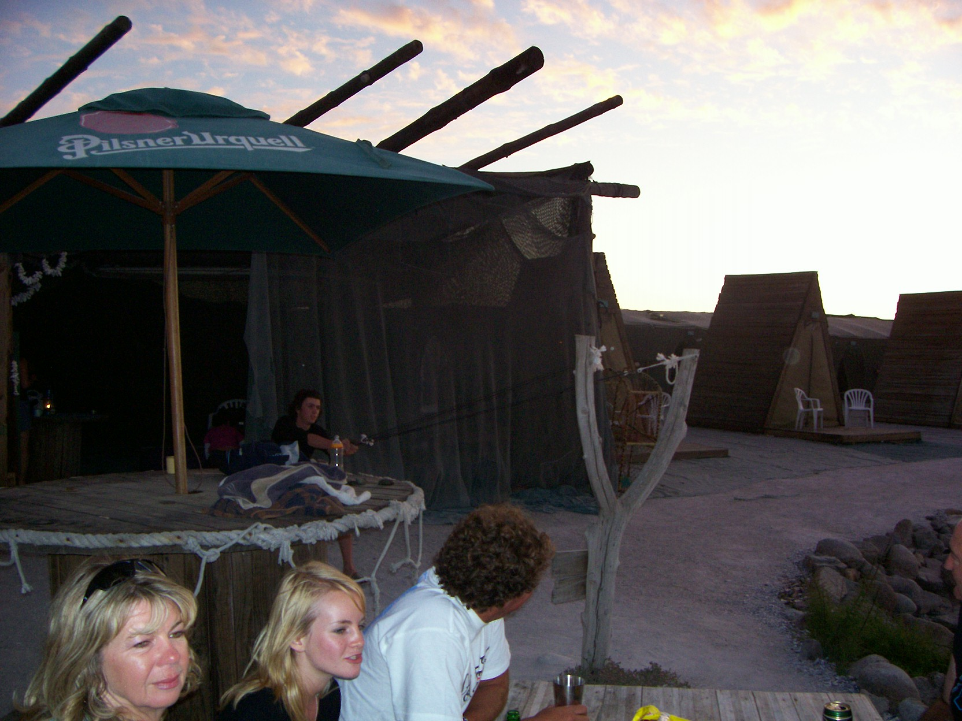
A huge catapult

So if you’re looking for something to do, whether it’s spring, summer, winter or autumn, the Weskus has everything and more to offer.

Get out there and enjoy.

Until next time, “Keep on tripping!”

